The Hagerman-Dexter Soil and Water Conservation District reserves the right to reject any and all bids.

All bids must be submitted no later than
July 23, 2020, 3:30 p.m. MST
Bids will be opened and awarded
July 24, 2020, 9 a.m. MST at
300 N. Pennsylvania Suite #3, Roswell, NM 88201

Bidders need not be present.
E-mailed or faxed bids are not accepted.

Send bids to:

Rebecca Healy, CPO
Attn: Hagerman-Dexter Soil and Water Conservation District
300 N Pennsylvania Suite #3
Roswell, NM 88201
Telephone: 575-208-3315

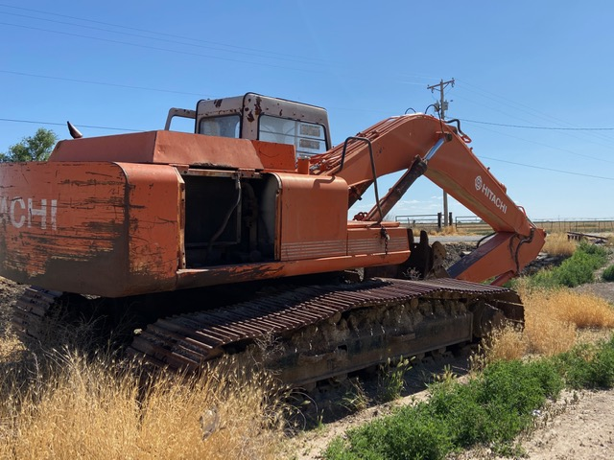
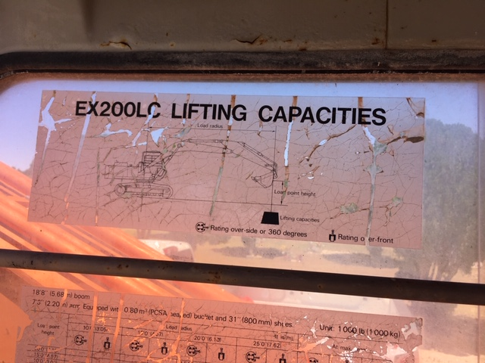
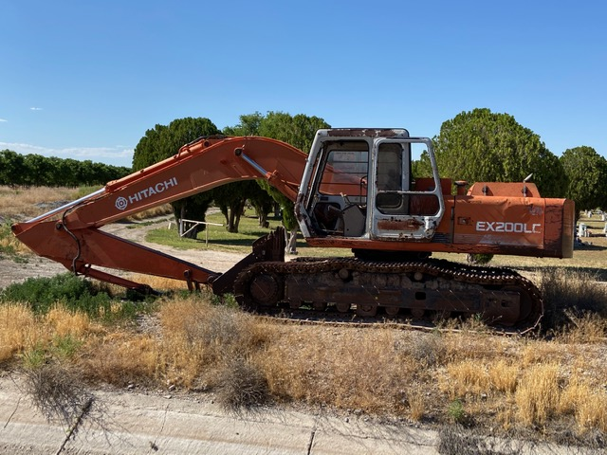
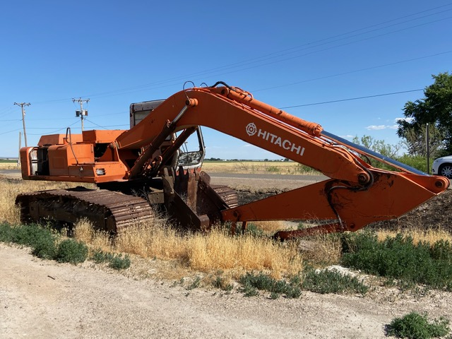
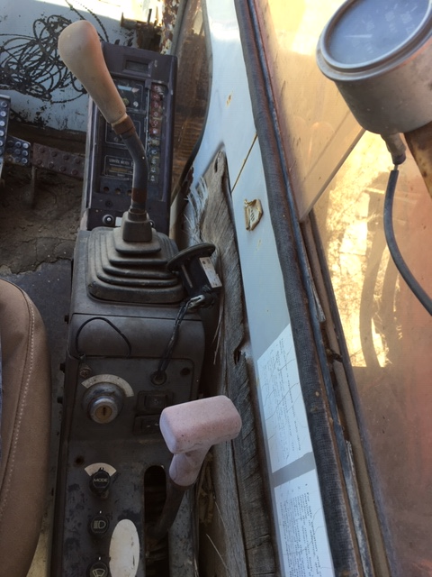
1987 Hitatchi Model EX200LC Excavator with 482 hours
6 cylinder
Has some bad oil leaks on the big cylinders
Currently located on the corner of E. Morgan Rd. and Shoshoni Rd. at the Hagerman Cemetery
For Sale “AS IS, WHERE IS”
Instructions to Bidders
- All bid sheets and this form must be executed and submitted in a sealed envelope. The face of the envelope shall contain in addition to the above address, the words “Excavator ITB”. Bids not submitted on this response form may be subject to rejection.
- Bids not signed shall be rejected.
- Address and mark bid as indicated above. The Hagerman/Dexter SWCD ASSUMES NO RESPONSIBILITY FOR UNMARKED ENVELOPES BEING CONSIDERED FOR AWARD.
- Telephonic bids, fax, and/or e-mail bids will not be accepted.
- Bids, amendments thereto or withdrawal requests received after the time advertised for opening will be void regardless of when they were mailed.

General Provisions
- Bidders’ Qualifications: Bidders must, upon request of the Hagerman/Dexter SWCD, furnish satisfactory evidence of their ability to perform in accordance with the terms and conditions of these specifications. The Hagerman/Dexter SWCD reserves the right to make the final determination as to the bidder’s ability to perform as requested herein.
- Bidders’ Responsibility: Each bidder shall fully acquaint themselves with conditions relating to the scope and restrictions attending the execution of the conditions of this Invitation to Bid. It is expected that this will sometimes require on-site observation. The failure or omission of a bidder to acquaint themselves with existing conditions shall in no way relieve them of any obligation with respect to this Invitation to Bid or the contract.
- Specifications: Any deviations from specifications indicated herein must be clearly pointed out; otherwise, it will be considered that the prices bided are in strict compliance with these specifications, and successful bidder(s) will be held responsible therefore. Deviations must be explained in detail on separate attached sheet(s).
- Rejection of Bids: The Hagerman/Dexter SWCD reserves the right to reject any and all bids, and to waive technicalities. Ambiguous bids which are uncertain as to terms, price, or compliance with specifications may be rejected or otherwise disregarded. NMSA 1978, § 13-1-82 and 13-1-84.
- Award Criteria: Award will be made to the HIGHEST responsive and responsible bidder, who submits a responsive bid which is the most advantageous to Hagerman/Dexter SWCD, provided that price bided is acceptable to the Hagerman/Dexter SWCD.

The Hagerman/Dexter SWCD may reject in whole or in part any or all bids as deemed in the best interest of the District. In the event that identical bids are received, the winning bidder shall be awarded by lottery.

The foregoing is a bid to dispose of surplus property for the benefit of the Hagerman/Dexter SWCD. If the response, in whole or in part, does not appear to be serving this objective, the Hagerman/Dexter SWCD shall be under no obligation to proceed with said disposal.

- Authority to Debar or Suspend:
  - The Hagerman/Dexter SWCD shall have the authority to suspend a person or firm from consideration for award of contracts, provided that doing so is in the best interest of Hagerman/Dexter SWCD, and that there is probable cause for debarment.
  - Causes for Debarment or Suspension. The causes for debarment or suspension shall include, but are not limited to the following:
    - Failure to pay for all items awarded.
    - Failure to pay for all items awarded and remove from the Hagerman/Dexter SWCD’s property within time allowed.
    - Deliberate failure without good cause to perform in accordance with the specifications or within the time limit provided in the contract.
    - Any other cause the Hagerman/Dexter SWCD determines to be so serious and compelling as to affect responsibility as a responsive bidder.
Terms and Conditions
- Upon award of contract under this bid, the persons, partnership, association, or corporation to whom the award is made must comply with the laws of New Mexico which require such persons or entity to be authorized and/or licensed to do business in this State. Notwithstanding the fact that applicable statues may exempt or exclude the successful bidder from requirement that it be authorized and/or licensed to do business in this State, by submission of this signed bid, the bidder agrees to subject themself to the jurisdiction and process of the courts of the State of New Mexico as to all matters and disputes arising or to arise under the contract and the performance thereof, including any questions as to the liability for taxes, licenses or fees levied by the State.
- The property is bided for sale “AS IS” and “WHERE IS” at the point indicated in this Invitation to Bid. Hagerman/Dexter SWCD makes no guarantee or warranty (express or implied) of the description, condition, usefulness, merchantability of fitness for any purpose, and those submitting bids are expected to examine the property and determine for themselves information they desire concerning it. Hagerman/Dexter SWCD reserves the right to withdraw items from the sale.
- The successful bidder(s) must assume all liability that may be incurred in connection with removal of the property from the premises where it is sold.
- Hagerman/Dexter SWCDs responsibility for the property bided by it ceases with its award to the successful bidder(s), but reasonable precaution will be taken to ensure delivery of the property in practically the same condition at the time of release as at the time of examination.
- Successful bidder(s) must pay for and remove ALL items awarded. The successful bidder(s) has no option to reject certain items. If rejection does occur by the successful bidder(s), they will be subject to debarment or suspension as outlined in No.6 under General Provisions.
- The successful bidder(s) or their accredited agent will be responsible for the removal of the property at their expense within ten (10) days after receipt of notification. In any event, this time shall not exceed fifteen (15) day, otherwise, title to the property reverts back to Hagerman/Dexter SWCD with no refund and successful bidder(s) will be subject to debarment or suspension as outlined in No.6 under General Provisions.
- WAIVER: The Hagerman/Dexter SWCD reserves the right to accept or reject any and all bids or to waive any general provisions, special provisions, or minor specification deviations when considered to be in the best interest of Hagerman/Dexter SWCD.
- INDEMNIFICATION: The successful bidder shall indemnify and hold harmless the Hagerman/Dexter SWCD, its agents, servants, and employees, from any and all losses, expenses, damages, demands, and claims by any person in connection with or arising out of any injury, or alleged injury, to persons (including death), or damage or alleged damage to property and/or the environment sustained, or alleged to have been sustained, as the result of the bidder’s performance of work in connection with this Invitation to Bid or breach of this Invitation to Bid and the bidder shall defend any suit or action brought against the Hagerman/Dexter SWCD or any of its agents or employees, based on any such alleged injury or damage, and pay all damages, costs, and expenses, including attorney’s feed in connection therewithin or resulting there from.

Hagerman/Dexter SWCD
Surplus Property Response Form

Bidder Information:
Bidder’s Name: _________________________________________________________________
Complete Mailing Address: ________________________________________________________
Phone Number: ____________________________ Cell Number: _________________________

Description: Bid Amount:
1987 Hitachi Model EX200LC Excavator $_____________________________

I certify that this bid is made without prior understanding, agreement, or connection with any corporation, firm, or person submitting a bid for the same materials, supplies, or equipment, and is in all respects fair and without collusion or fraud. I agree to abide by all conditions of this bid and certify that I am authorized to sign this bid.

________________________________________________________________________________________________________
Signature Date

Submit Response in a sealed envelope labeled “Excavator ITB” to:
Rebecca Healy, CPO
Attn: Hagerman/Dexter SWCD
300 N. Pennsylvania Suite #3
Roswell, NM 88201

(575) 208-3315

Due by Thursday July 23, 2020 at 3:30 pm MST

